Data Operations - Transformation

Definition
# Source: AI Source: Provided by: [Data Path: Persons Table -> ID Column: 1, Name_En Column: Motasem Essam] -> From: [Chatgpt (GPT‑5 Mini)] on [12/10/2025]
Transformation is the process of converting data from one format, structure, or value system into another to make it suitable for analysis, storage, or integration.
- It often follows collection, cleaning, and standardization.
- Transformation ensures data consistency, compatibility, and usability.

Key Idea
# Source: AI Source: Provided by: [Data Path: Persons Table -> ID Column: 1, Name_En Column: Motasem Essam] -> From: [Chatgpt (GPT‑5 Mini)] on [12/10/2025]
- Raw data may come in different formats, scales, or structures.
- Transformation aligns data into a standard form for further processing or analysis.
- Example: Converting dates, normalizing numerical values, encoding categorical variables.

Types of Transformation
# Source: AI Source: Provided by: [Data Path: Persons Table -> ID Column: 1, Name_En Column: Motasem Essam] -> From: [Chatgpt (GPT‑5 Mini)] on [12/10/2025]
- Normalization / Scaling
  - Original: Test scores 50–95, 0–10 rating
  - Transformed: All scores scaled to 0–100 range
- Encoding Categorical Data
  - Original: "Male", "Female"
  - Transformed: 0 = Male, 1 = Female
- Date/Time Transformation
  - Original: "12/31/2025", "31-Dec-2025"
  - Transformed: "2025-12-31" (ISO format)
- Currency Conversion
  - Original: 100 USD, 90 EUR
  - Transformed: All converted to USD using exchange rates
- Text Transformation
  - Original: "Pending Approval", "awaiting approval"
  - Transformed: "Approval Pending" (standardized text)

Advantages
# Source: AI Source: Provided by: [Data Path: Persons Table -> ID Column: 1, Name_En Column: Motasem Essam] -> From: [Chatgpt (GPT‑5 Mini)] on [12/10/2025]
- Makes data consistent and comparable
- Facilitates accurate analysis and reporting
- Enables integration from multiple sources
- Supports automated processing and modeling

Disadvantages
# Source: AI Source: Provided by: [Data Path: Persons Table -> ID Column: 1, Name_En Column: Motasem Essam] -> From: [Chatgpt (GPT‑5 Mini)] on [12/10/2025]
- May introduce errors if done incorrectly
- Can be time-consuming for large datasets
- Requires knowledge of original and target data formats
- Over-transformation can lead to loss of raw data context

Transformation vs Validation

Transformation
# Source: AI Source: Provided by: [Data Path: Persons Table -> ID Column: 1, Name_En Column: Motasem Essam] -> From: [Chatgpt (GPT‑5 Mini)] on [12/10/2025]

- Purpose: To convert data into a suitable format, structure, or value system for analysis, storage, or integration.
- Focus: Modifying or standardizing data.
- Examples:
  - Scaling test scores to 0–100
  - Converting dates to ISO format
  - Encoding "Male"/"Female" as 0/1
  - Converting currencies to a single standard
- Key Idea: Changes the form or value of the data so it can be used consistently.

Validation
# Source: AI Source: Provided by: [Data Path: Persons Table -> ID Column: 1, Name_En Column: Motasem Essam] -> From: [Chatgpt (GPT‑5 Mini)] on [12/10/2025]

- Purpose: To check that the data is accurate, complete, and meets predefined rules before processing or storage.
- Focus: Ensuring data correctness and integrity.
- Examples:
  - Format check: Email addresses must contain “@”
  - Range check: Age must be between 0 and 120
  - Uniqueness check: Student ID must be unique
  - Mandatory field check: Name cannot be empty
- Key Idea: Does not change the data (usually); it verifies that the data is valid.

Summary:
# Source: AI Source: Provided by: [Data Path: Persons Table -> ID Column: 1, Name_En Column: Motasem Essam] -> From: [Chatgpt (GPT‑5 Mini)] on [12/10/2025]
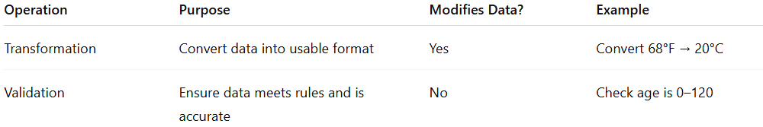
Operation | Purpose | Modifies Data? | Example
Transformation | Convert data into usable format | Yes | Convert 68°F → 20°C
Validation | Ensure data meets rules and is accurate | No | Check age is 0–120
✅ In short: Transformation changes data, while Validation checks data.

Transformation vs Data Cleaning

Transformation
# Source: AI Source: Provided by: [Data Path: Persons Table -> ID Column: 1, Name_En Column: Motasem Essam] -> From: [Chatgpt (GPT‑5 Mini)] on [12/10/2025]
- Purpose: To convert or modify data into a format, scale, or structure suitable for analysis, storage, or integration.
- Focus: Changing how the data is represented.
- Examples:
  - Converting dates to ISO format (01/12/2025 → 2025-12-01)
  - Encoding categorical variables (Male/Female → 0/1)
  - Scaling numeric values (e.g., 0–100)
  - Converting currencies to a single unit

Data Cleaning
# Source: AI Source: Provided by: [Data Path: Persons Table -> ID Column: 1, Name_En Column: Motasem Essam] -> From: [Chatgpt (GPT‑5 Mini)] on [12/10/2025]
- Purpose: To correct, remove, or standardize inaccurate, incomplete, or inconsistent data before analysis.
- Focus: Improving data quality rather than changing its representation.
- Examples:
  - Removing duplicates
  - Handling missing data
  - Correcting text formats (Ali, ALI → Ali)
  - Removing outliers
  - Standardizing units or categorical values

Key Difference
# Source: AI Source: Provided by: [Data Path: Persons Table -> ID Column: 1, Name_En Column: Motasem Essam] -> From: [Chatgpt (GPT‑5 Mini)] on [12/10/2025]
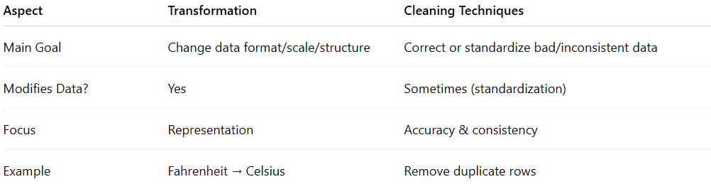
Aspect | Transformation | Cleaning Techniques
Main Goal | Change data format/scale/structure | Correct or standardize bad/inconsistent data
Modifies Data? | Yes | Sometimes (standardization)
Focus | Representation | Accuracy & consistency
Example | Fahrenheit → Celsius | Remove duplicate rows
✅ Note: Some cleaning techniques overlap with transformation — e.g., unit conversion or text standardization can be seen as both cleaning and transformation.

Transformation vs Data Cleaning Techniques - standardization
# Source: AI Source: Provided by: [Data Path: Persons Table -> ID Column: 1, Name_En Column: Motasem Essam] -> From: [Chatgpt (GPT‑5 Mini)] on [12/10/2025]
now we’re talking about a specific overlap. Transformation and standardization are related, but still not exactly the same. Let me clarify carefully.

Standardization (a cleaning technique)
# Source: AI Source: Provided by: [Data Path: Persons Table -> ID Column: 1, Name_En Column: Motasem Essam] -> From: [Chatgpt (GPT‑5 Mini)] on [12/10/2025]
- Purpose: To make data consistent and comparable.
- Focus: Ensuring that values follow a uniform format, scale, or representation.
- Examples:
  - Text standardization: "Ali", "ALI" → "Ali"
  - Unit conversion: 68°F, 20°C, 293K → 20°C
  - Date formats: "01/12/2025", "Dec 1, 2025" → "2025-12-01"
  - Categorical values: "Male", "M" → "Male"

Transformation
# Source: AI Source: Provided by: [Data Path: Persons Table -> ID Column: 1, Name_En Column: Motasem Essam] -> From: [Chatgpt (GPT‑5 Mini)] on [12/10/2025]
- Purpose: To convert data into a format suitable for analysis or integration.
- Focus: Changing the representation, structure, or scale of the data.
- Examples:
  - Scaling numeric data: 0–100 → 0–1
  - Encoding categorical variables: "Male", "Female" → 0, 1
  - Log transformations of skewed data for analysis
  - Combining columns or splitting fields for processing

Key Overlap
# Source: AI Source: Provided by: [Data Path: Persons Table -> ID Column: 1, Name_En Column: Motasem Essam] -> From: [Chatgpt (GPT‑5 Mini)] on [12/10/2025]
- Standardization is a type of transformation, because it changes the representation of data to make it consistent.
- But not all transformations are cleaning — e.g., scaling numbers or encoding categories is a transformation but not cleaning.

✅ Summary:
# Source: AI Source: Provided by: [Data Path: Persons Table -> ID Column: 1, Name_En Column: Motasem Essam] -> From: [Chatgpt (GPT‑5 Mini)] on [12/10/2025]
- Standardization = cleaning + transformation (it cleans inconsistencies and transforms data format)
- Transformation (general) ≠ all cleaning techniques — only some overlap, like standardization.

Transformation vs Data Cleaning Techniques - Correcting Data Formats

Correcting Data Formats (a cleaning technique)
# Source: AI Source: Provided by: [Data Path: Persons Table -> ID Column: 1, Name_En Column: Motasem Essam] -> From: [Chatgpt (GPT‑5 Mini)] on [12/10/2025]
- Purpose: To fix inconsistencies in how data is represented so it’s correct and uniform.
- Focus: Making data readable, consistent, and valid.
- Examples:
  - Dates: "12-01-2025", "2025/01/12" → "2025-12-01"
  - Numbers: "1,000.00" → 1000.00
  - Text: "Ali " → "Ali"
This is part of data cleaning — it removes errors or formatting inconsistencies.

Transformation
# Source: AI Source: Provided by: [Data Path: Persons Table -> ID Column: 1, Name_En Column: Motasem Essam] -> From: [Chatgpt (GPT‑5 Mini)] on [12/10/2025]
- Purpose: To convert data into a new format for analysis or integration.
- Focus: Changing the structure, scale, or type of data.
- Examples:
  - Scaling numbers: 0–100 → 0–1
  - Encoding categories: "Male", "Female" → 0, 1
  - Combining columns: FirstName + LastName → FullName
  - Log-transforming values for analysis

Key Difference
# Source: AI Source: Provided by: [Data Path: Persons Table -> ID Column: 1, Name_En Column: Motasem Essam] -> From: [Chatgpt (GPT‑5 Mini)] on [12/10/2025]
- Correcting data formats is cleaning-focused: you fix errors and inconsistencies.
- Transformation can include format changes but often goes beyond cleaning, e.g., preparing data for modeling, aggregating, or scaling.
✅ Bottom line:
- Correcting data formats is a type of transformation, but not all transformations are cleaning.
- Transformation is a broader operation that can include cleaning, standardization, encoding, scaling, et

Transformation vs Updating

Updating
# Source: AI Source: Provided by: [Data Path: Persons Table -> ID Column: 1, Name_En Column: Motasem Essam] -> From: [Chatgpt (GPT‑5 Mini)] on [12/10/2025]
- Purpose: To modify existing data in a database or file to keep it accurate, current, and relevant.
- Focus: Changing existing values without altering the overall structure.
- Examples:
  - Changing a student’s score from 80 → 85
  - Correcting a phone number in a customer database
  - Updating a product price
Updating is directly modifying stored data for correctness or currency.

Transformation
# Source: AI Source: Provided by: [Data Path: Persons Table -> ID Column: 1, Name_En Column: Motasem Essam] -> From: [Chatgpt (GPT‑5 Mini)] on [12/10/2025]
- Purpose: To convert data into a new form or structure for analysis, integration, or modeling.
- Focus: Changing format, scale, type, or combining data, not just fixing errors.
- Examples:
  - Scaling 0–100 scores → 0–1 for a machine learning model
  - Combining FirstName + LastName → FullName
  - Converting categorical text to numerical codes
Transformation is often preparation for analysis or aggregation, not just correcting existing values.

Key Difference
# Source: AI Source: Provided by: [Data Path: Persons Table -> ID Column: 1, Name_En Column: Motasem Essam] -> From: [Chatgpt (GPT‑5 Mini)] on [12/10/2025]
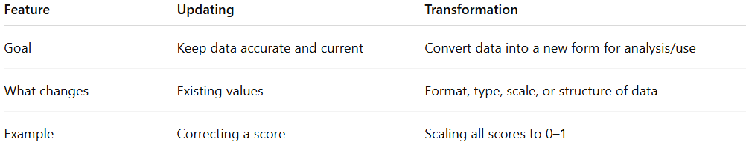
Feature | Updating | Transformation
Goal | Keep data accurate and current | Convert data into a new form for analysis/use
What changes | Existing values | Format, type, scale, or structure of data
Example | Correcting a score | Scaling all scores to 0–1
✅ Bottom line:
- Updating = correcting/modifying existing data
- Transformation = converting data into a different form or structure
- Some updates may involve transformation (e.g., changing units or format), but not all transformations are updates.

